**Software testing** – This testing checking and completness of the software.

There are Two types of Software

1.Manual Testing

2.Automation Testing

What is BUG-defect life cycle also known as bug life cycle is the journey of a defect cycle which a defect goes trough during its lifetime .

Why is the bug life cycle important-

The bug should go through the life cycle to be closed a specific life cycle ensurers that the process is standardized .the bug attains different state in the lifecycle.

What is a bug in SDLC-

A software bug is an error or fault in a computer program making it behave in unexpected ways.

Error-The of checking the software then occur is called error

Defect-Error found b tester called defect

Bug- defect life cycle also known as bug life cycle is the journey of a defect cycle which a defect goes trough during its lifetime .

Fault-

Failure-

**BUG Life Cycle-**

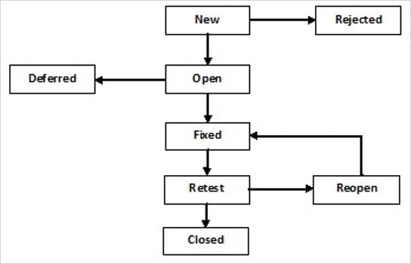

**Level Of Testing- There are four level of testing**

**1.Unit Testing**

**2.intergration Testing**

**3.System Testing**

**4.Acceptance Testing**

Unit Testing-Unit testing is **a software development process in which the smallest testable parts of an application, called units, are individually and independently scrutinized for proper operation**. This testing methodology is done during the development process by the software developers and sometimes QA staff.

Integration testing-Integration testing -- also known as integration and testing (I&T) -- is **a type of software testing in which the different units, modules or components of a software application are tested as a combined entity**. However, these modules may be coded by different programmers.

System Testing-**System Testing** is a level of testing that validates the complete and fully integrated software product. The purpose of a system test is to evaluate the end-to-end system specifications. Usually, the software is only one element of a larger computer-based system. Ultimately, the software is interfaced with other software/hardware systems. System Testing is defined as a series of different tests whose sole purpose is to exercise the full computer-based system.

Acceptance testing-Acceptance Testing is the last phase of software testing performed after System Testing and before making the system available for actual use.

**The seven principles of testing**

* Testing shows the presence of defects, not their absence. ...
* Exhaustive testing is impossible. ...
* Early testing saves time and money. ...
* Defects cluster together. ...
* Beware of the pesticide paradox. ...
* Testing is context dependent. ...
* Absence-of-errors is a fallacy.

**WBT- White Box Testing**

White Box testing is done by coder

It is also called as –code level testing,unit testing,clear box testing.

In the white box testing whenever coder completness his code writing,he check or compile code then if any bug found coder have to solve it

Coder can not send code tested without doing white box testing

Coder check or test onl positive scenario.

White box testing has purpose to test correctness and completness of the program

What do you verify in White Box Testing?

White box testing involves the testing of the software code for the following:

* Internal security holes
* Broken or poorly structured paths in the coding processes
* The flow of specific inputs through the code
* Expected output
* The functionality of conditional loops
* Testing of each statement, object, and function on an individual basis

**BBT- Black Box Testing**

**Black Box Testing** is a software testing method in which the functionalities of software applications are tested without having knowledge of internal code structure, implementation details and internal paths. Black Box Testing mainly focuses on input and output of software applications and it is entirely based on software requirements and specifications. It is also known as Behavioral Testing.

requirements and specifications. It is also known as Behavioral Testing.

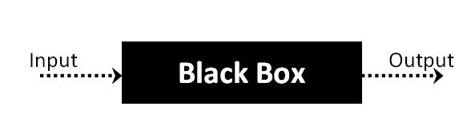

black box testing is also know as system &function testing

this testing is done by tester.

Overall functionality get checked in this type.

Tester check internal functionality depend upon external functionality.

Ex

ternal behaviour testing is calles bbt

### How is Black Box Testing done?

The steps for carrying out Black Box Testing are as follows:

* At first, the application to be tested is studied to find out the requirements and specifications. The SRS (Software Requirement Specification) document should be maintained with accuracy.
* The inputs and test scenarios are evaluated. Efficient and time-saving techniques are incorporated.
* Test cases are generated. These test cases are made in such a way that the input range is maximum.
* The test cases are then processed to obtain the output. The generated output is compared with the expected output to understand the success of the result.
* If there are unsuccessful steps, they are sent to the [software development teams](https://openxcell.com/software-development-company/) for fixing.
* The defects are fixed.
* Run the tests again for confirmation.

### Types of Black Box Testing

There are three types of black-box testing namely- functional testing, non-functional testing, and regression testing.

#### 1. Functional Testing

If a particular function or feature of the software is tested then it is categorized under black-box testing. For example, if the correct pin is entered then money can be transferred and if the incorrect pin is entered, the transaction fails.

**Examples of Functional Testing are:**

* Unit Testing
* Smoke Testing
* Sanity Testing
* Integration Testing  `
* User Acceptance Testing

#### 2. Non-functional Testing-

If Black box testing is used to test more aspects other than functionalities and features it comes under the umbrella of non-functional testing. Non-functional testing revolves around examining how well the system does a job.

* Capable of working when the load is maximum
* Compatible to work with different devices
* Easy to use

#### 3. Regression Testing

Regression testing helps to find if the new codes have had any ill effects on the already existing ones. Regression testing is basically selecting complete or parts of test cases that had already been executed to make sure that the functionalities do have any abnormalities. In easy words, it tests to make sure that the new codes do not have side effects on the old codes. The different regression testing tools are Selenium, Quick Test Professional or QTP, Rational Functional Tester.

### Techniques of Black Box Testing-

#### Equivalence Partitioning

As the name suggests, the inputs are partitioned into groups or more literally partitions. Only one input from every group is tested to find the results. The inputs are usually numeric values or a set of values or Boolean conditions. For example, if the field accepts an integer in the range 1 and 20 then:

Valid Equivalence Class Partition: 1 to 20 inclusive.

Invalid Equivalence Class Partition: Less than 1 or more than 20, decimal numbers or alphabets and other non-numeric characters.

-

#### Boundary Value Testing

In boundary value analysis the answers are within specific boundaries. The two ends, the inner and the outer limits are considered in this type of testing. For example, an offer is valid for customers between the ages of 18 and 30 only. Therefore other values such as 17, 18, 30, or 31 can be tested to check whether the inputs are accepted.

**State Transition Testing**

This testing technique uses the inputs, outputs, and the state of the system during the testing phase. It checks the software against the sequence of transitions or events among the test data.

Based on the type of software that is tested, it checks for the behavioral changes of a system in a particular state or another state while maintaining the same inputs.

For example, A login page will let you input username and password until three attempts. Each incorrect password will be sent the user to the login page. After the third attempt, the user will be sent to an error page. This state transition method considers the various states of the system and the inputs to pass only the right sequence of the testing.

**Decision Table Testing**

This approach creates test cases based on various possibilities. It considers multiple test cases in a [decision table](https://reqtest.com/requirements-blog/a-guide-to-using-decision-tables/) format where each condition is checked and fulfilled, to pass the test and provide accurate output. It is preferred in case of various input combinations and multiple possibilities

**Graph-Based Testing:**

It is similar to a decision-based test case design approach where the relationship between links and input cases are considered.

**Error Guessing Technique:**

This method of designing test cases is about guessing the output and input to fix any errors that might be present in the system. It depends on the skills and judgment of the tester.

Compari

**Control flow testing**-checking the data flow control

Example

Class simple

{

Public static void main(string arg[])

{

Int n=20;

If(n%2=0)

{

System.out.print(a+”is even number”);

}

Else

{

System.out print(a+”is odd number”);

}  
}

}

Data flow testing

N=20

Path=1,2,3,4,5,8

Output-1,2,4,6,8,10,12,14,16,18,20

Contrl flow-

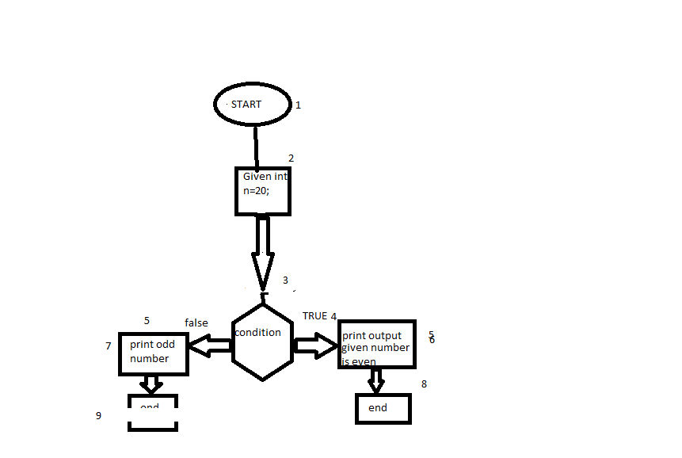

Branch coverage testing

Branch cover-1-2-3-4-5-8

Branch no cover-5-7-9

Statement coverage testing

Total number of statements-9

Number of executed statement-6

Statement coverage=6/9*100

=66.66%

Decision coverage statement

Number of decision coverage excerised=1

Total number of decisionoutcomes=2

Decision coverage=1/2*100=50%

Branch coverage

Branch coverd-1,2,3,4,5

Branch not covered-6